# DESN705 Assessment Two: Design Report

## Section 1: Exploring the space of possibilities

1. Intervention Strategy

Complete the *Intervention Strategy* and insert a picture of your completed tool. The purpose of this tool is to explore possible ideas of ways you can intervene in the system.

2. Insights - Identify three possible interventions. Discuss why you consider these to be important ways to intervene in your system.

By mapping all the potential interventions available to us in our local community we discovered that physical structures, as well as delays and rules & regulations, are fundamental ways we can intervene in the system of South Auckland.

With physical structures, one of the main interventions is hiring more security guards for local malls and other community spaces. The other intervention is increasing the amount of lighting in public spaces such as parks and walkways. By focusing on tangible interventions in this area, we identified real ways to increase the feeling of safety in our community. While researching the safety concerns earlier in the semester I identified that the feeling of being unsafe is a complex issue, with a tangle of real concerns as well as more abstract feelings perpetuated by the media. By having the focus on physical structures and increasing the level of security people feel in public spaces, hopefully, our community can start to feel safer.

Looking into delays in our system, we identified two different ways we could intervene to reduce delays. The first was aiming to reduce congestion and roadworks in South Auckland by hiring more construction workers, as well as incentivising trades. This would reduce the time people spend sitting in their cars idle, and potentially reduce car theft. Additionally, by reducing congestion, we aim to make our roads feel safer which will also contribute to the overall feeling of safety in our community. Secondly, we explored the idea of reducing the delay in emergency services reaching members of our community. My group members and I, as well as others we interviewed, expressed frustration at the delays in our emergency services arriving as well as the scope of intervention they had, especially with the police.

Finally, we looked into rules and regulations, particularly with our public transport system. While discussing the rules and regulations we could intervene in citizens not wearing masks on public transport came up. As university students, we all use various forms of public transport weekly, and all reported seeing people not wearing their masks on public transport. While there are transport officers at some stations, train stations in particular, there is not a lot we have seen being done about people who don’t wear their masks. In the world post-pandemic, it seems that some members of our community have forgotten the real fear Covid-19 brought to the community. We proposed that more should be done to encourage people to wear their masks, if only to ensure all members of our community feel safe using public transport.

As I will discuss in section 2, these issues are all interconnected. We found with these interventions in particular that they had a flow-on effect: by hiring more security guards and construction workers as well as Police Officers, more individuals would find themselves in stable work with a good income and therefore may be less likely to commit crime. As we work on these interventions, we may find ourselves making positive changes in our community that we have not considered.

## Section 2: Designing the intervention model

1. Intervention Model - The intervention model describes the principles and activities that will enable change in a system. Complete your *Intervention Model* and insert a picture of your completed connectors.

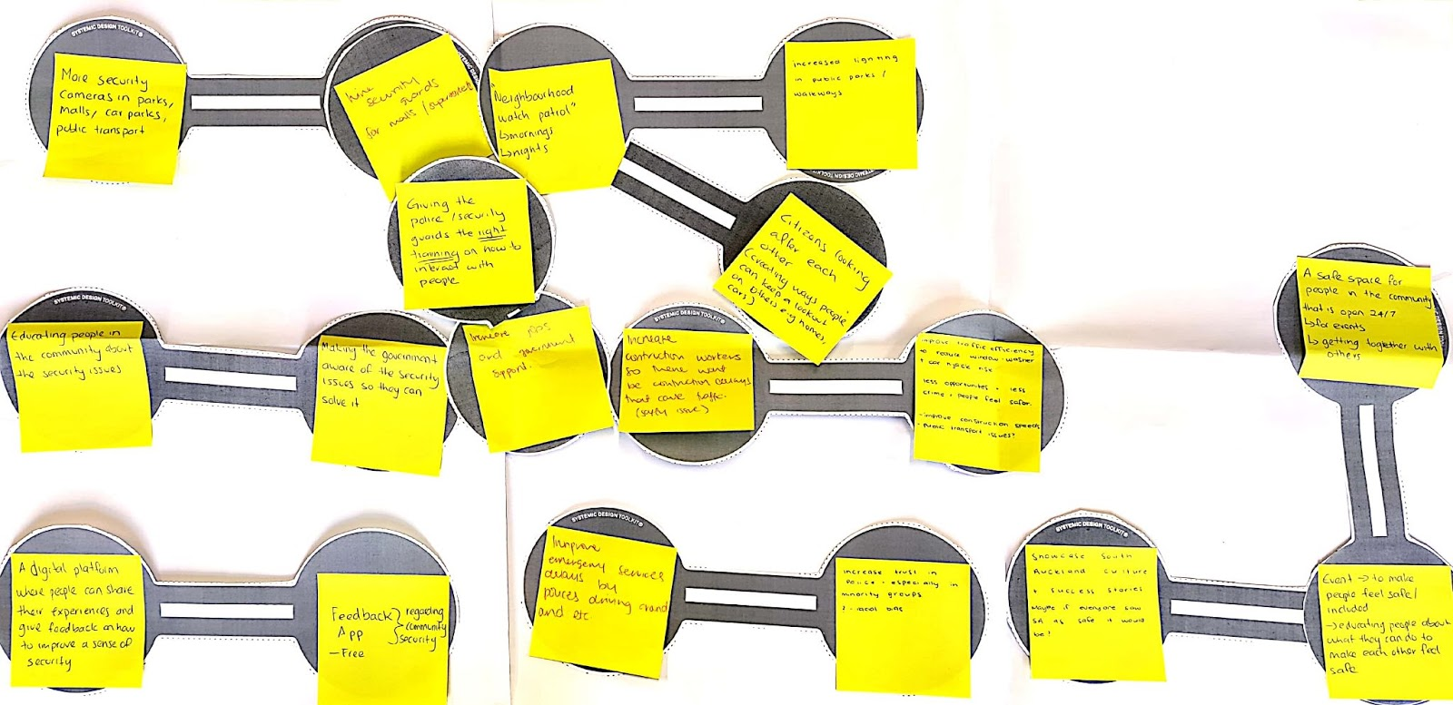



2. Discuss

Describe your intervention model and discuss the different aspects that are needed to enact and enable change in your community.

In this exercise, my group and I took the interventions from section one and attempted to group them in significant and meaningful ways. By doing so we found that we had one main group of interconnected circles and three smaller groups of interconnected circles.

In our main group, we connected increased security guards in public spaces, with a neighbourhood watch system at night and in the morning, as well as with increased lighting in public spaces. We also connected the increase in security to an increase in Government support, which branched off in two directions. The first linked Government support to ensuring the Government is aware of the safety issues and educating the public on security issues in the community. The second linked Government support with hiring more construction workers to ease traffic congestion.

This is quite a complex intervention model with many moving parts and many aspects that connected to more than just what we mapped in this model. From this, it is clear to me that increasing security and safety in South Auckland may not be as difficult as I once thought, but that the difficulty lies in choosing an intervention to start with, especially with the potential for any one of these interventions to run into one another.

In our three smaller models, we connected the concept of a digital platform where people could share their experiences with an app for feedback, potentially to local councils and/or the police and other emergency services. We also connected an increase in the trust our local community has in the police with an increase in the availability of our emergency services. Finally, we connected the idea of having a safe space for people in the community to gather, with events being held to connect our communities, as well as an opportunity to showcase South Auckland success stories, and potentially shift the narrative of how South Auckland is portrayed in the media.

By looking at the main complex model as well as the three smaller models it becomes clearer how the issues of security and safety in South Auckland is both tangible and intangible. While we can work to increase the security available in local malls, supermarkets, and other public spaces, the community might not feel safer till there is more trust in our police force. We can increase the lighting available in currently dark public spaces such as parks and walkways, but will our community feel safe if our media is continuing to tell us that people shouldn’t feel safe in South Auckland after dark? The reality is that all of our possible interventions are connected, and should be addressed in one way or another.

## Section 3: Fostering the Transition

1. Transition Model - The roadmap for transition aims to identify your desired goal and plan your intervention considering time and space. Complete your *Fostering Transition Model* and insert a picture of your model.

2. Discuss

Discuss your intervention model.

a. Minimum viable model:

Immediately, we would look at putting lights in public spaces which are currently dark, develop a training programme for those interested in going into security, create a reward system for individuals that interact with our initiatives, as well as raise awareness for the changes that would be coming in the future. These interventions tackle the tangible changes that increase safety such as the lights and training programme but also primes the community for the bigger cultural shifts that may take months or even years to complete. We also recognise that without the support from the local community, any changes we implement are not likely to have long-lasting impacts. This is why our reward system is so key to our minimum viable model and our short term interventions.

b. Intermediate version:

In the intermediate term, we would continue to increase the lighting available in public spaces, as well as adding security cameras in areas with high activity such as public parks. We would continue to incentivise and support individuals wanting to become certified security guards by subsiding the training programme. We would also find partnerships in the wider Auckland area, which will bring in funds allowing us to be more flexible with our interventions.

In the intermediate term, we would also start building a community space where people in the local community would feel free to socialise. With this, we must develop this space with the community to address the needs of our community. We would look at decolonising design to ensure that our space is safe for Maori and Pacific people, as well as looking at political design to work with our local councils. In addition to this, we would also start the development of our website and app, focusing on features such as education and feedback. By ensuring our community has a safe space to connect both online and in-person will continue the cultural shift towards safety we are hoping to achieve. This space aims to connect the individuals and smaller communities within the wider South Auckland community, and hopefully, as South Auckland gets to know the people in it, it will start to feel safer.

c. Full version:

In the long term, we will continue all the efforts outlined earlier, such as placing lights in dark public spaces, as well as increasing the training efforts for security guards in local malls and supermarkets. We would also continue to work with the community of South Auckland to develop safe spaces where our community can come and share their experiences. In addition to this, we would finalise our app and website to further that safe space to create an online community. Covid has taught us that we could become socially isolated at any time and fostering safe spaces both in person, and online is equally important. Through these efforts, it would be key for us to keep the system of South Auckland in mind and develop and improve these interventions based on feedback from the community. We must keep in mind the real issues at the origin of these interventions – supporting the local community of South Auckland in a post-COVID-19 world.

In addition to continuing to work on these interventions, we would also start a conversation around re-training or updating the training in regards to the Police, as well as potentially putting in regulations in terms of media reporting. We recognise that some of the more complex aspects of individuals not feeling safe in South Auckland comes from a mistrust in the Police, as well as the way the media reports on events happening in South Auckland. These issues will require deep cultural change, but ultimately this change needs to be led by our community. By encouraging the media to report on the success stories happening in our community, as well as having those hard conversations with the Police, we expect a few key outcomes. Firstly, we hope that by reporting on crimes in South Auckland in a more neutral way our community will feel safer. It may be difficult for our community to feel safe when the media is constantly telling us how unsafe South Auckland is. Secondly, by reporting on the positive aspects we hope to further the interconnection between the cultural aspects of our community. Finally, by opening the conversation with the Police, we may be able to tackle the mistrust our community has, and thus make South Auckland safer.

## Section 4: Reflection on Systems Thinking

1. Systems thinking

Reflecting on this project, what was your experience like of doing a system thinking process? Would you use this again to tackle a complex problem?

I found this process incredibly interesting. When compared to previous design thinking papers which mainly focused on the creation of solutions to problems, I found systems thinking a much more intellectually challenging process. It broke down the wicked problem of security and safety in South Auckland into an easier understand map of smaller interconnected issues. I also found the process of mapping how the smaller issues connected fascinating and very enjoyable.

While I may use systems thinking again, I might not use it again for such a broad issue. Understanding the limitations of this particular project I found that attempting to solve the complex issues of South Auckland when our definition and perspective of South Auckland differed so wildly was difficult. Myself living in Botany, which may be referred to by some people as East Auckland, is going to leave me with a different understanding of slightly different issues from my colleague who lives in Pokeno to the far south of South Auckland. This added another layer of complexity to what is already a complex issue.

It was interesting however to see where our perspectives of the common issue intersected and where they didn't. One group member reported that she didn't feel like her part of South Auckland was as dangerous as people suggested, while I on the other hand feel unsafe to walk my dog after dark as there are no lights in the off lead dog reserve near my house. The other group member also reported that she didn't feel as safe in public spaces such as in local malls and on public transport, while the issue reported mostly by the individuals I interviewed was focused more on house break-ins.

Overall, I think it would be interesting to apply the lessons I have learnt from this process to other similarly complex issues.

2. Your values and the system

How do you think your perspective of the system may have been shaped by your values or biases?

I went into this project thinking I already knew what issues South Auckland was facing, and some potential ways we could solve these. However, I was surprised to see the issue of safety and security come up in my interviews, as well as those of my group members. I know that South Auckland has had a stigma around crime and safety, especially perpetuated by the media, but I hadn't stopped to think that this may be an issue we could attempt to map and intervene in. I also hadn't considered the impact of the media representation as well as the mistrust in the police, and how these intangible aspects would have an effect on the community as a whole. From this experience, I am a lot more aware of how I fit into the system of South Auckland, but also how the overall issue of safety impacts me and my daily life. Before this project, I hadn't considered just how much I would enjoy lights in the public reserve walkways I use daily, and how that would greatly change how safe I feel being out and about in my community.

3. Systems thinking tools

What was the most useful systems thinking tool that you used? What was the most challenging? Why?

I found the assumption maps and the interconnected circles the most useful. I found it confronting mapping the experiences over time of the two individuals I interviewed, as they both had vastly different experiences in the community. It was interesting to compare the insight of the teacher who had seen many of her students drop out of high school to take up full-time employment, with my work colleague who felt less safe out late at night while playing football. I also found the interconnected circle tool incredibly interesting as a way to map out potential interventions, and how they connected and through each other. It put the complex issues more visually and allowed us to understand greater the complexity of the issue of safety in South Auckland.

However, I found the transitional design tool a little harder to grasp. As I have outlined in this report the issue of safety in South Auckland is both a tangible and intangible issue. When mapping potential interventions across the immediate, medium-term and long term it was a lot easier to consider the possible tangible interventions such as putting in lights in public spaces. Mapping possible intangible interventions such as those tied with cultural changes and shifts were a lot more difficult to map as they are complex issues within themselves. It was also difficult for me to understand the flow-on effect of the interventions we have modelled, and I found this tool ended up being quite abstract when looking at fostering the transition over the long term.